Water System Analysis

[Project Name]

Application # [XX-XXX]

[Month Year]

Prepared for:

[Developer Name]

[Address 1]

[Address 2]

Prepared by:

[Consultant Name]

[Address 1]

[Address 2]

[Insert Licensed Engineer Stamp]

Table of Contents

List of Tables 2

Appendices 2

Chapter 1 - Introduction 3

Introduction 3

Project Overview 3

Purpose of Study 3

Chapter 2 – Design Criteria 4

Water Duty Factors 4

Design Criteria 5

Chapter 3 – Projected Water Demands 7

Projected Water Demands 7

Reservoir Storage Capacity 7

Pumping Capacity 8

Chapter 4 – Existing Water Facilities 9

Existing Water Facilities 9

Chapter 5 – Water System Analysis 10

Hydraulic Modeling 10

Water Analysis Summary 10

System Pressures 11

Velocity 11

Head Loss 11

Reservoir Storage Capacity Evaluation 12

Pumping Capacity Evaluation 12

Chapter 6 - Recommended Water Facilities 13

Distribution System 13

Reservoir Storage 13

Pumping 13

# List of Tables

**TABLE 2-1 Water Duty Factors……………………………………………………………..………………………………….…….X**

**Table 2-2 Design Criteria……….……………………………………………………………………………………………………….X**

**Table 3-1 Projected Water Demands……….………………………………………………………………..……….….…….X**

**Table 3-2 Reservoir Storage Requirements………………………………………………………………..….…….…….X**

**Table 3-3 Pumping Capacity Requirements………………..………………………………………..………..…….……..X**

**Table 5-1 Summary of Water Analysis……………….…………………………………………………………………….….X**

**Table 5-2 reservoir Storage Capacity Evaluation………...………………………………………………...……….X**

**Table 5-3 Pumping Capacity Evaluation…………………….………………………………..………………….…………..X**

# Attachments

Attachment A Location Map

Attachment B Site Plan

Attachment C Existing water facility map

Attachment D Copy of evmwd fire flow test

Attachment E copy of fire department fire flow requirements

Attachment F Hydraulic Model analyis and node/pipe diagram

Attachment G Static Pressure Calculations and static pressure map

Attachment H Proposed water facility map

Attachment I copy of evmwd master plan Existing storage capacity

Attachment J copy of evmwd master plan Existing pump capacity

# Chapter 1 - Introduction

## Introduction

This report provides a water system analysis for the [Project Name] project in the Elsinore Valley Municipal Water District (EVMWD or District). This report will provide information concerning projected water demands, existing facilities, and recommended facilities associated with serving the project.

## Project Overview

[Describe the project location, project area, land use, residential lot EDU, and building area]. **Attachment A** depicts the project location and **Attachment B** is the preliminary site plan for the project.

## Purpose of Study

The project is located within the Elsinore Valley Municipal Water District for water service. Water service for the project will be provided by EVMWD’s [XXXX] Zone. The purpose of this report is to establish the potable water facilities that will be required for the development of the project within the zone.

# Chapter 2 – Design Criteria

This section represents the design criteria used to evaluate recommended water system improvements for the project. The criteria utilized in this study are in accordance with the District’s 2023 Design Standards and 2024 Water System Master Plan.

## Water Duty Factors

Table 2-1 presents the water duty factors (WDF) used for projecting water demands for the project.

| Table 2-1 Water Duty Factors | | |
| --- | --- | --- |
| Land Use Category | WDF (gpd/unit) | Unit |
| Single Family Residential | 500 | Dwelling Unit (DU) |
| Condominium/Townhome Residential | 300 | DU |
| Business Park | 800 | acre |
| General Commercial | 2,300 | acre |
| Limited Industrial | 700 | acre |
| Open Space - Recreation | 2,300 | acre |
| Public Institutional | 1,300 | acre |
| Hillside Residential (1) | 1,400 | acre |
| Very Low Density Residential  (0.1 – 0.5 DU/acre) | 700 | acre |
| Low Density Residential (0.5‑2 DU/acre) | 1,200 | acre |
| Low Medium Density Residential  (2-4 DU/acre) | 2,000 | acre |
| Medium Density Residential  (4-6 DU/acre) | 2,200 | acre |
| Medium High Density Residential  (6-12 DU/acre) | 2,400 | acre |
| High Density Residential  (12-24 DU/acre) | 2,600 | acre |
| Mixed Use (24 DU/acre max) | 1,700 | acre |

## Design Criteria

Table 2-2 presents the design criteria used for sizing of EVMWD facilities for the project.

| Table 2-2 Design Criteria | | |
| --- | --- | --- |
| Description | Value | Units |
| **Peaking Factor** |  |  |
| Maximum Day Demand (MDD) | 1.75 of Average Day Demand (ADD) | psi |
| Peak Hour Demand (PHD) | 3.5 of ADD | psi |
| **System Pressures** |  |  |
| Maximum Pressure - MDD conditions | 125 | psi |
| Minimum Pressure - PHD conditions, new facilities | 60 | psi |
| Minimum Pressure - PHD conditions, existing facilities | 40 | psi |
| Minimum Pressure - MDD with fire flow conditions | 20 | psi |
| **Maximum Pipeline Velocity** |  |  |
| Transmission Pipelines (≥ 12-inch diameter) – PHD conditions | 6 | fps |
| Transmission Pipelines in 1434 Loop Zone between Reservoirs – PHD conditions | 3 | fps |
| Distribution Pipelines (<12-inch diameter) – PHD conditions | 4 | fps |
| Existing Pipelines under MDD plus fire flow conditions | 10 | fps |
| Pumping Station suction piping – MDD conditions | 8 | fps |
| **Maximum Head Loss** |  |  |
| Transmission Pipelines (≥ 12-inch diameter) – PHD conditions | 3 | ft/1000 ft |
| Distribution Pipelines (<12-inch diameter) – PHD conditions | 15 | ft/1000 ft |
| **Reservoir Storage Volume** |  |  |
| Operational Storage Volume | 30% of MDD | |
| Fire Flow | Highest fire flow requirement per zone under MDD | |
| Emergency Storage Volume | 100% of MDD | |
| **Pump Station Capacity** |  |  |
| By Pressure Zone, for zones with gravity storage | MDD with firm transfer/booster capacity between zones | |
| By Pressure Zone, for zones without gravity storage | PHD with firm transfer/booster capacity between zones AND  PHD+Fire with total transfer/booster capacity between zones | |

# Chapter 3 – Projected Water Demands

This chapter provides the projected water demands, pumping capacity and reservoir storage requirements for the project based on the information presented above and using the criteria from Chapter 2.

## Projected Water Demands

**Table 3-1** presents the projected average day water demand (ADD), maximum day demands (MDD) and peak hour demands (PHD).

| Table 3-1 Projected Water Demands ADD, MDD and PHD | | | | | | | |
| --- | --- | --- | --- | --- | --- | --- | --- |
| Description/Land Use | Area (Acres) | EDU | WDF (gpd/unit) | Unit | ADD  (gpd) | MDD  (gpd) | PHD  (gpd) |
|  |  |  |  |  |  |  |  |
|  |  |  |  |  |  |  |  |
|  |  |  |  |  |  |  |  |
|  |  |  |  |  |  |  |  |
|  |  |  |  |  |  |  |  |
|  |  |  |  |  |  |  |  |
|  |  |  |  |  |  |  |  |
|  |  |  |  |  |  |  |  |
|  |  |  |  |  |  |  |  |
|  |  |  |  |  |  |  |  |
|  |  |  |  |  |  |  |  |
|  |  |  |  |  |  |  |  |
|  |  |  |  |  |  |  |  |
|  |  |  |  |  |  |  |  |
| **Total** |  |  |  |  |  |  |  |

## Reservoir Storage Capacity

**Table 3-2** summarizes the reservoir storage requirements.

| Table 3-2 Reservoir Storage Requirements | | | | | |
| --- | --- | --- | --- | --- | --- |
| Pressure Zone | MDD  (MG) | Operational Storage Volume  (MG) | Emergency Storage Volume  (MG) | Fire Flow Storage  (MG) | Total Required Storage  (MG) |
|  |  |  |  |  |  |
| **Total** |  |  |  |  |  |

## Pumping Capacity

**Table 3-3** summarizes the pumping capacity requirements.

| Table 3-3 Pumping Capacity Requirements | | | |
| --- | --- | --- | --- |
| Pressure Zone | MDD  (mgd) | Pumping Duration  (hr) | Total Required  Pumping Capacity  (gpm) |
|  |  | 16 |  |
| **Total** |  |  |  |

# Chapter 4 – Existing Water Facilities

The existing water facilities in the vicinity of the projects are in the existing **[XXXX]** water service zones. **Attachment C** presents a map showing the boundaries of the project.

## Existing Water Facilities

[Describe the existing water facilities vicinity of the project, pipe size, reservoir size, pumping capacity, pressure zone and the project elevation range.]

# Chapter 5 – Water System Analysis

This chapter presents the recommended water system improvements required to provide service to the [Project Name] project. An evaluation of distribution, storage, and pumping facilities is provided.

## Hydraulic Modeling

Hydraulic modeling was performed to verify the proposed onsite water system’s ability to serve the project. A fire flow test conducted at the [fire flow location] was used as the basis for the hydraulic model. he results of the fire flow test are included in **Attachment D** for reference. The fire flow requirement of X,XXX gpm at 20 psi for a X hour duration was used per Fire Departments condition letter attached as **Attachment E**. The Hazen-Williams equation for determining head losses in pipes and a Hazen-Williams pipe roughness coefficient “C” of 120 is used for all pipes. The detailed hydraulic modeling results are provided in **Attachment F** for the following scenarios along with the pipe/node diagram.

1. Average Day Demand
2. Maximum Day Demand
3. Maximum Day Demand plus Fire Flow of X,XXX gpm at a X hour at Node XX.
4. Peak Hour Demand

## Water Analysis Summary

**Table 5-1** summarizes the water analysis results.

| Table 5-1 Summary of Water Analysis | | | | | |
| --- | --- | --- | --- | --- | --- |
| Description | Criteria Value | Units | Minimum Value | Maximum Value | Criteria Met  (Yes/No) |
| **System Pressures** |  |  |  |  |  |
| Maximum Pressure - MDD conditions | 125 | psi | N/A |  |  |
| Minimum Pressure - PHD conditions, new facilities | 60 | psi |  | N/A |  |
| Minimum Pressure - MDD with fire flow conditions | 20 | psi |  | N/A |  |
| **Maximum Pipeline Velocity** |  |  |  |  |  |
| Transmission Pipelines (≥ 12-inch diameter) – PHD conditions | 6 | fps |  | N/A |  |
| Transmission Pipelines in 1434 Loop Zone between Reservoirs – PHD conditions | 3 | fps |  | N/A |  |
| Distribution Pipelines (<12-inch diameter) – PHD conditions | 4 | fps |  | N/A |  |
| **Maximum Head Loss** |  |  |  |  |  |
| Transmission Pipelines (≥ 12-inch diameter) – PHD conditions | 3 | ft/1000 ft | N/A |  |  |
| Distribution Pipelines (<12-inch diameter) – PHD conditions | 15 | ft/1000 ft | N/A |  |  |

## System Pressures

[Describe the system pressures, lot elevations, HGL and indicate if the design criteria were met. If there is less than 60 psi, the pad elevation needs to be increased, watermain from a higher-pressure zone must be extended to the project, or public booster station must be constructed upon District approval. If more than 40 EDU exceed 125 psi, pressure reducing stations will be required.] **Attachment G** provides a detailed breakdown of static pressures by project/lot and a figure that shows the lots that have less than a static pressure of 60 psi with the reservoir level at 10 feet above bottom of tank and more than 125 psi static pressure with the reservoir full.

## Velocity

[Describe the velocity ranges and indicate if the design criteria were met. If the velocity criteria are not met, consider changing the pipe slope or size.]

## Head Loss

[Describe the head loss range and indicate if the design criteria were met. If the head loss is not met, consider increasing the pipe size.]

## Reservoir Storage Capacity Evaluation

**Table 5.2** notes the storage capacity evaluation for the project.

|  |  |  |  |  |
| --- | --- | --- | --- | --- |
| Table 5-2 Storage Capacity Evaluation | | | | |
| Pressure Zone | Existing Surplus Storage1  [A] | Required Storage  [B] | Available Required Storage  [A-B] | Deficient |
| (MG) | (MG) | (MG) | (Yes/No) |
|  |  |  |  |  |
|  |  |  |  |  |
| Note 1. Existing surplus storage from Table 7-6 from Master Plan attached in Attachment I | | | | |

## Pumping Capacity Evaluation

**Table 5.3** notes the pumping capacity evaluation for the project.

|  |  |  |  |  |  |
| --- | --- | --- | --- | --- | --- |
| Table 5-3 Pumping Capacity Evaluation | | | | | |
| Pressure Zone | Existing Pumping Surplus1  [C] | Required Pumping Capacity  [D] | Available Pumping Capacity  [C-D] | Deficient | |
| (gpm) | (gpm) | (gpm) | (Yes/No) | |
|  |  |  |  |  | |
|  |  |  |  |  | |
| Note 1. Existing pumping surplus from Table 7-7 and 7-8 from Master Plan attached in Attachment J | | | | | |

# Chapter 6 - Recommended Water Facilities

This chapter presents the recommended water system improvements required to provide service to the [Project Name] project. **Attachment H** presents the proposed water facilities to be constructed for the project.

## Distribution System

[Describe the proposed pipe size and zone. The water system shall have two sources of water and the system must be looped wherever possible. The minimum main size shall be 8-inch for residential and 12-inch for commercial and industrial. Parallel mains may be required by the District to be installed to avoid connecting services to the water mains >12-inch in diameter. No 10-inch or 14-inch diameter pipe shall be allowed]

## Reservoir Storage

[Describe the improvements required to provide the reservoir storage capacity in the zone or indicate if no additional storage is required].

## Pumping

[Describe the improvements required to provide the pumping capacity in the zone or indicate if no additional pumping is required].

Attachment A

Location Map

Attachment B

Site Plan

Attachment C

Existing water facility map

Attachment D

Copy of evmwd fire flow test

Attachment E

copy of fire department fire flow requirements

Attachment F

Hydraulic Model analyis and node/pipe diagram

Attachment G

Static Pressure Calculations and static pressure map

| Summary of Static Pressure | | | | | |
| --- | --- | --- | --- | --- | --- |
| Project/Lot Elevation (ft) | | Reservoir Level (HGL) | | Static Pressure (psi) | |
| Min | Max | 10 Feet Above Bottom of Tank | Full | Min (Based on Reservoir Level 10 Feet Above Bottom of Tank) | Max (Based on Reservoir Full) |
|  |  |  |  |  |  |
|  |  |  |  |  |  |
|  |  |  |  |  |  |
|  |  |  |  |  |  |
|  |  |  |  |  |  |
|  |  |  |  |  |  |
|  |  |  |  |  |  |
|  |  |  |  |  |  |
|  |  |  |  |  |  |
|  |  |  |  |  |  |
|  |  |  |  |  |  |
|  |  |  |  |  |  |
|  |  |  |  |  |  |
|  |  |  |  |  |  |
|  |  |  |  |  |  |
|  |  |  |  |  |  |
|  |  |  |  |  |  |
|  |  |  |  |  |  |
|  |  |  |  |  |  |

Attachment H

Proposed water facility map

Attachment I

copy of evmwd master plan Existing storage capacity

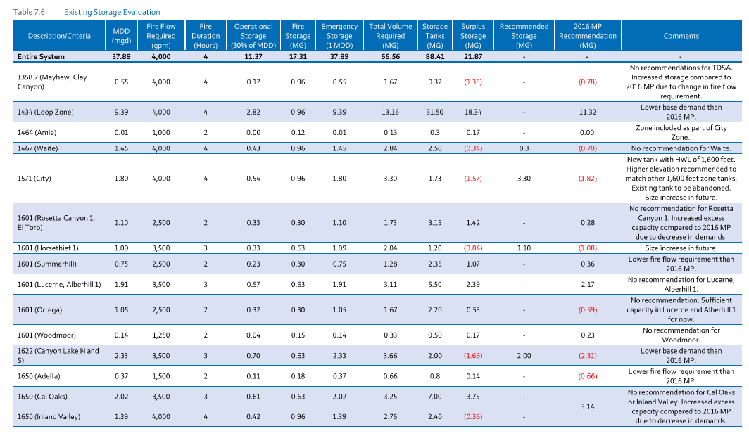

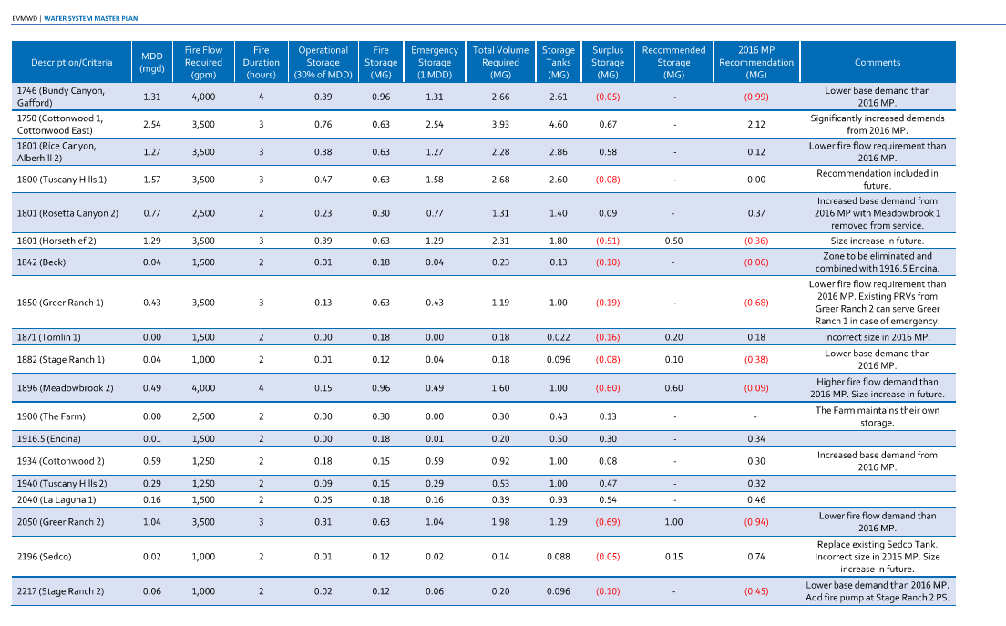

Attachment J

copy of evmwd master plan Existing pumping capacity

